

**KINGSWAY CHRISTIAN COLLEGE**

**Year 12 ATAR Physics 2017**

**Task 2**

**Test: Gravity, Satellites, Motion and Torque.**

Name _______________________________________________

Date due: ***Friday, 17 March 2017***

**Time allowed 80 minutes**

|  |  |  |
| --- | --- | --- |
| **Section A** | **Available mark** | **Student mark** |
| Question 1 | 7 |  |
| Question 2 | 7 |  |
| Question 3 | 7 |  |
| Question 4 | 8 |  |
| Question 5 | 17 |  |
| Question 6 | 14 |  |
| Question 7 | 8 |  |
| Question 8 | 10 |  |
| Question 9 | 8 |  |
|  |  |  |
|  |  |  |
| ***Total marks*** | ***86*** |  |
| ***%*** | ***100*** |  |

**Section A**: Short answer questions. Write the answers in the spaces provided.

1. A projectile is fired from position 1 on a very windy day and its path is affected by the wind effects (resistance and drag). The initial velocity is shown as $\vec{u}$.

a) Draw and label on the same diagram, the path the projectile would have taken, if there was no wind. [2]

b) Use arrows to indicate the total velocity and total acceleration at the positions labelled 2, 3, 4, 5 and 6. Point 6 is just before landing. [5]

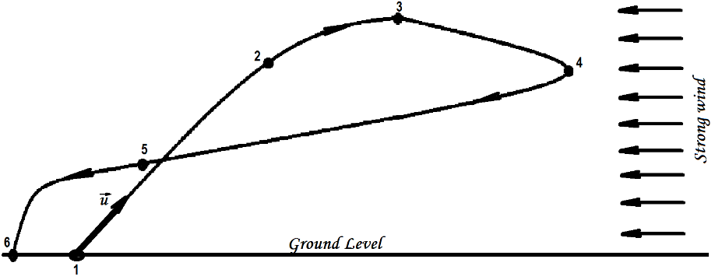

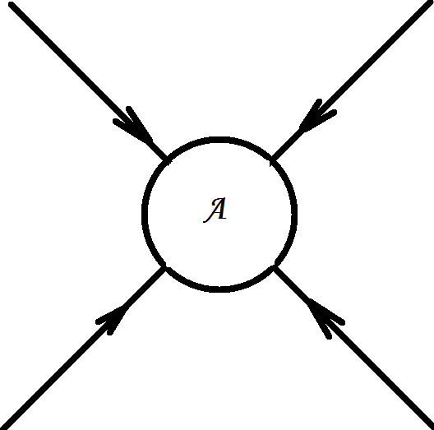2. a) The gravitational field around an object A with mass m is shown below. Draw the gravitational field for an object B of the same size but with mass 2m. [2]

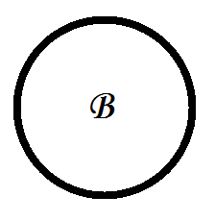

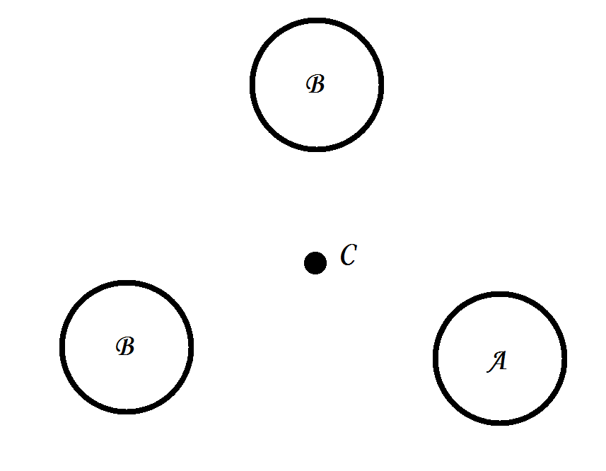  
  
b) Objects A (mass m), B (mass 2m) and C (mass m) are positioned as shown. C at the centre and A and 2 × B at the vertices of an equilateral triangle.  
Draw vectors to represent the following:  
i) The force on C due to A, [1]  
ii) The force on C due to the top B [1]  
iii) The force on C due to the bottom B [1]  
iv) The resultant force on C due to A and 2 × B. [2]

3. a) Two rowers, who can row at the same speed in still water, set off across a river at the same time. One heads straight across and is pulled downstream somewhat by the current. The other one heads upstream at an angle so as to arrive at a point opposite the starting point. Which rower reaches the opposite side first? [3]

b) A boat that can move in still water with a speed $v_{bw}=1.85 m.s^{-1}$ heads directly across the river whose current is $v_{ws}=1.20 m.s^{-1}$.  
  
i) What is the velocity (magnitude and direction) of the boat relative to the shore, $\vec{v_{bs}}$? [2]  
  
  
  
  
  
  
  
  
  
  
  
  
  
ii) If the river is 110 m wide, how long will it take to cross and how far downstream will the boat be then? [2]

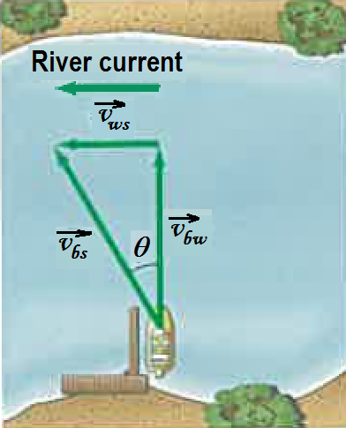

***N***

4. Two boxes, ***m1*** = 1.0 kg with friction = 0.20 times the normal reaction, and ***m2*** = 2.0 kg with friction = 0.10 times the normal reaction, are attached with an inextensible cord and placed on a plane inclined at ***θ = 30o*** .   
a) Draw a free body diagram of the forces acting on ***m1***. [2]

b) Draw a free body diagram of the forces acting on ***m2***. [2]

c) Write the equations of motion in a direction parallel and perpendicular to the plane and solve for the tension in the cord and the acceleration of the system. [4]

**Section B: Problem solving.** Answer the questions in the spaces provided. Show all working.

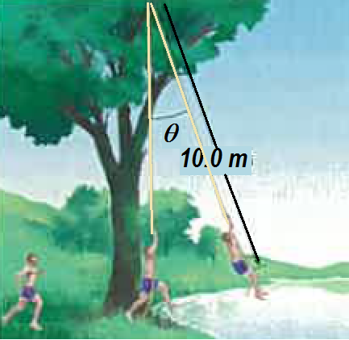5. a) A 65-kg student runs at 7.0 m.s−1 grabs a rope, and swings out over a lake. He releases the rope when his speed is zero.   
i) What is the angle ***θ*** when he releases the rope? [2]

ii) What is the tension in the rope just before he releases it? [2]

iii) What is the maximum tension in the rope? [2]

b) A stunt driver wants to make his car jump over eight cars parked side by side below a horizontal ramp.

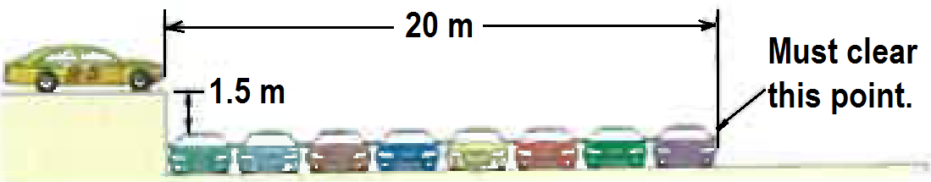

i) With what minimum speed in km.h−1 must he drive off the horizontal ramp? The vertical height of the ramp is 1.5 m above the cars, and the horizontal distance he must clear is 20 m. [3]  
  
  
  
  
  
  
  
  
  
  
  
ii) If the ramp is now tilted upward, so that ''take-off angle" is 10o above the horizontal, what is the new minimum speed in km. h−1 ? [3]

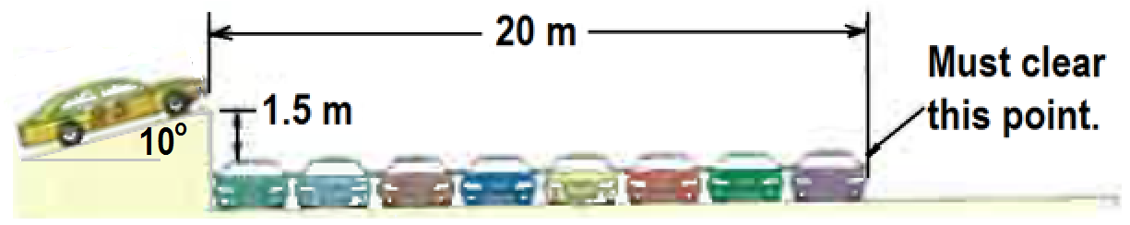

iii) What is velocity of the stunt car as it crosses “Must clear this point.” [3]

iv) What is the maximum height of the stunt car above the top of the lined cars? [2]

6. a) What is the difference between a geosynchronous and a geostationary satellite? [2]

b) Calculate the altitude of a geostationary satellite and give two uses of such a satellite. [3]

c) A 1800 kg satellite is orbiting the earth at an orbital radius of 6.87 × 106 m. Calculate  
i) The gravitational force of attraction on the satellite [2]

ii) The gravitational field strength of the earth at the orbit [2]

iii) The acceleration due to gravity of the earth at the orbit [1]

iv) The period of the satellite in this orbit [1]

v) The orbital speed of the satellite [1]

vi) The satellite is to be moved to an orbit with double the period. What will be the new orbital radius of the satellite? [2]

7. A 1500 kg car is negotiating a circular round about with a radius r = 100m. At the instant shown it is heading North at 60 km.h−1.

a) Calculate the sideways friction force, F required to keep the car in circular motion. [2]

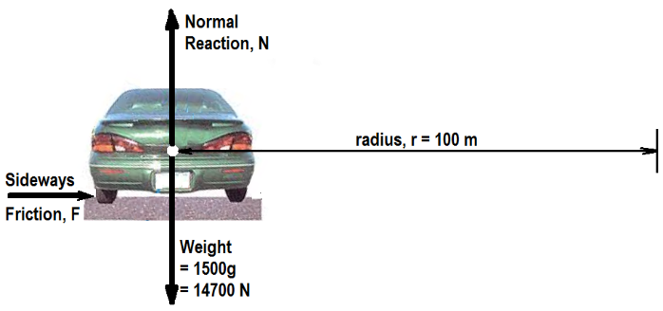

b) The same car is now travelling at optimal speed (no tendency of sideways friction) on a ramp inclined at ***θ*** = ***30o.*** The pathway is still circular with radius r = 100 m. Calculate the optimal speed required on this ramp. [2]

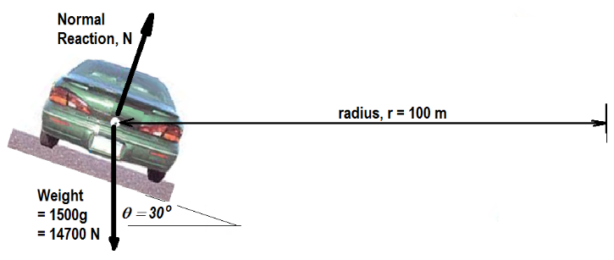

c) The car is still on the 30o ramp and on the circular path with radius = 100 m. However, this time a sideways frictional force of 600 N acts up the slope as shown. Calculate the normal reaction, N and the car speed in km.h−1. [4]

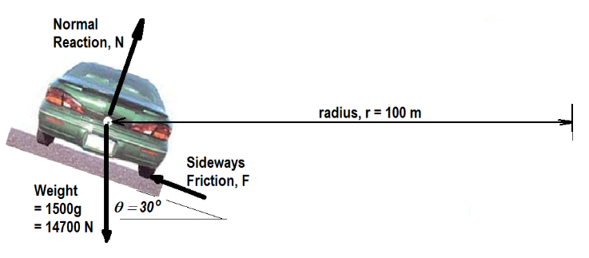

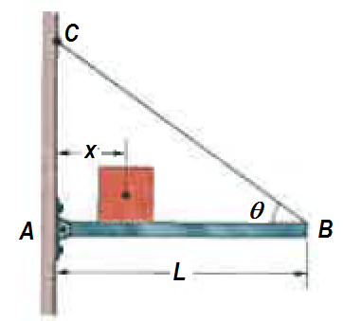8. a) The length L of the uniform bar is 3.00 m and its weight is 200 N. Also, let the block's weight W = 300 N and the angle ***θ = 30o***. The wire can withstand a maximum tension of 500 N.  
i) What is the maximum possible distance x before the wire breaks? [2]  
  
  
  
  
  
  
  
  
  
  
ii) With the block placed at this maximum x, what are the horizontal and vertical components of the force on the bar from the hinge at A? [2]

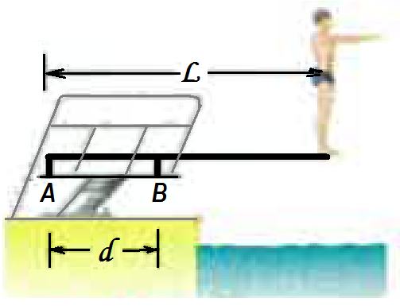b) A diver of weight 580 N stands at the end of a diving board of length L = 4.5 m and negligible mass. The board is fixed to two pedestals, A and B, separated by distance d = 1.5 m. Of the forces acting on the board, what are the

i) magnitude and direction (up or down) of the force from the left pedestal A. [2]

ii) magnitude and direction (up or down) of the force from the right pedestal, B? [2]

iii) Which pedestal (A or B) is being stretched, and which is being compressed? [2]

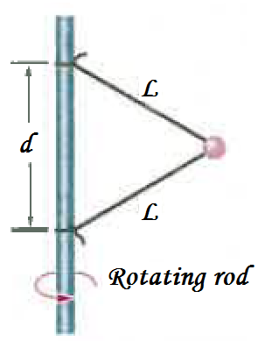9. A 15.0 N ball is connected by means of two massless strings, each of length L = 2.00 m, to a vertical, rotating rod. The strings are tied to the rod with separation d = 2.00 m and are taut. The tension in the upper string is 1530 N. What are the   
a) tension in the lower string, [2]

b) the net force $\vec{F_{net}}$ on the ball, and [2]

c) speed of the ball in m.s−1 and rpm [4]

END of Task 2.